**Stat 5100 Handout 2.6.1 – SAS: Inference with Multiple Predictors**

Example: (Table 7.1) Study seeks to relate (in females) amount of body fat (Y) to triceps skinfold thickness (X1), thigh circumference (X2), and midarm circumference (X3). Amount of body fat is expensive to measure, requiring immersion of person in water. This expense motivates the desire for a predictive model based on these inexpensive predictors.

Q1: Do thigh and midarm both have no effect on body fat when triceps is in the model?

Q2: Do the relationships among the predictors cause any problems in the fitted model?

**/* Input data */**

**data bodyfat;**

**input triceps thigh midarm body @@; cards;**

**19.5 43.1 29.1 11.9 24.7 49.8 28.2 22.8**

**30.7 51.9 37.0 18.7 29.8 54.3 31.1 20.1**

**19.1 42.2 30.9 12.9 25.6 53.9 23.7 21.7**

**31.4 58.5 27.6 27.1 27.9 52.1 30.6 25.4**

**22.1 49.9 23.2 21.3 25.5 53.5 24.8 19.3**

**31.1 56.6 30.0 25.4 30.4 56.7 28.3 27.2**

**18.7 46.5 23.0 11.7 19.7 44.2 28.6 17.8**

**14.6 42.7 21.3 12.8 29.5 54.4 30.1 23.9**

**27.7 55.3 25.7 22.6 30.2 58.6 24.6 25.4**

**22.7 48.2 27.1 14.8 25.2 51.0 27.5 21.1**

| **Pearson Correlation Coefficients, N = 20  Prob > |r| under H0: Rho=0** | | | | |
| --- | --- | --- | --- | --- |
|  | **body** | **triceps** | **thigh** | **midarm** |
| **body** | |  | | --- | | 1.00000 | |  | | |  | | --- | | 0.84327 | | <.0001 | | |  | | --- | | 0.87809 | | <.0001 | | |  | | --- | | 0.14244 | | 0.5491 | |
| **triceps** | |  | | --- | | 0.84327 | | <.0001 | | |  | | --- | | 1.00000 | |  | | |  | | --- | | 0.92384 | | <.0001 | | |  | | --- | | 0.45778 | | 0.0424 | |
| **thigh** | |  | | --- | | 0.87809 | | <.0001 | | |  | | --- | | 0.92384 | | <.0001 | | |  | | --- | | 1.00000 | |  | | |  | | --- | | 0.08467 | | 0.7227 | |
| **midarm** | |  | | --- | | 0.14244 | | 0.5491 | | |  | | --- | | 0.45778 | | 0.0424 | | |  | | --- | | 0.08467 | | 0.7227 | | |  | | --- | | 1.00000 | |  | |

**;**

**run;**

**proc corr data=bodyfat;**

**var body triceps**

**thigh midarm;**

**title1 'Correlation matrix';**

**run;**

**proc sgscatter data=bodyfat;**

**matrix body triceps thigh midarm/**

**markerattrs=(symbol=CIRCLEFILLED size=2pt);**

**title1 'Bodyfat Data';**

**run;**

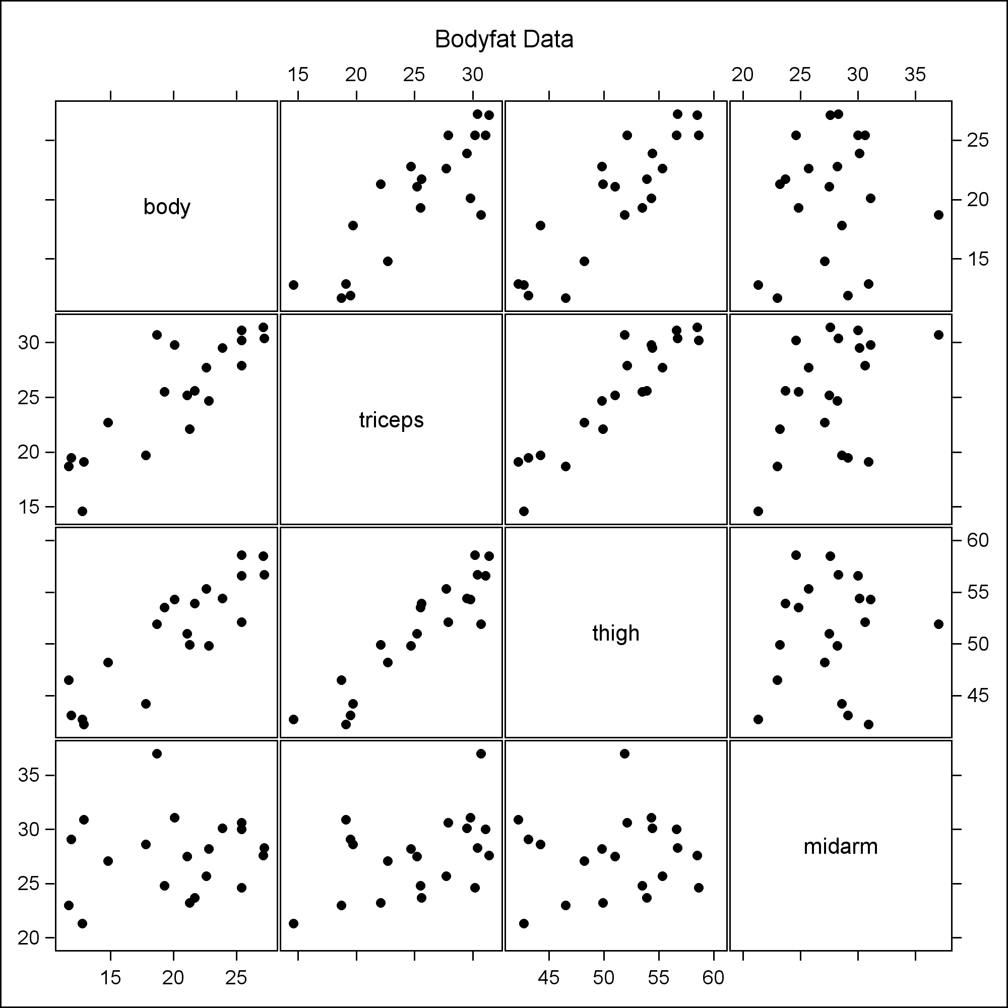

**/* Q1: Test whether thigh and midarm BOTH have**

**no effect on body when triceps is in the model */**

**proc reg data=bodyfat;**

**model body = triceps thigh midarm;**

**title1 'Bodyfat Regression';**

**title2 '(full model)';**

**run;**

|  |  |  |  |  |  |  |  |  |  |  |  |  |  |  |  |  |  |  |  |  |  |  |  |  |  |  |  |  |  |  |  |  |
| --- | --- | --- | --- | --- | --- | --- | --- | --- | --- | --- | --- | --- | --- | --- | --- | --- | --- | --- | --- | --- | --- | --- | --- | --- | --- | --- | --- | --- | --- | --- | --- | --- |
| |  | | --- | | ***Bodyfat Regression*** | | ***(full model)*** |  | **Analysis of Variance** | | | | | | | --- | --- | --- | --- | --- | --- | | **Source** | **DF** | **Sum of Squares** | **Mean Square** | **F Value** | **Pr > F** | | **Model** | 3 | 396.98461 | 132.32820 | 21.52 | <.0001 | | **Error** | 16 | 98.40489 | 6.15031 |  |  | | **Corrected Total** | 19 | 495.38950 |  |  |  | |

**proc reg data=bodyfat;**

**model body = triceps;**

**title1 'Bodyfat Regression';**

**title2 '(reduced model)';**

**run;**

|  |  |  |  |  |  |  |  |  |  |  |  |  |  |  |  |  |  |  |  |  |  |  |  |  |  |  |  |  |  |  |  |  |
| --- | --- | --- | --- | --- | --- | --- | --- | --- | --- | --- | --- | --- | --- | --- | --- | --- | --- | --- | --- | --- | --- | --- | --- | --- | --- | --- | --- | --- | --- | --- | --- | --- |
| |  | | --- | | ***Bodyfat Regression*** | | ***(reduced model)*** |  | **Analysis of Variance** | | | | | | | --- | --- | --- | --- | --- | --- | | **Source** | **DF** | **Sum of Squares** | **Mean Square** | **F Value** | **Pr > F** | | **Model** | 1 | 352.26980 | 352.26980 | 44.30 | <.0001 | | **Error** | 18 | 143.11970 | 7.95109 |  |  | | **Corrected Total** | 19 | 495.38950 |  |  |  | |

**data temp;**

**F = ( (143.11970-98.40489)/2 ) / ( 6.15031 );**

**p = 1-probf(F,2,16);**

**proc print data=temp;**

**title1 'Subset F-test, by hand';**

**run;**

|  |  |  |  |  |  |  |  |
| --- | --- | --- | --- | --- | --- | --- | --- |
| |  | | --- | | ***Subset F-test, by hand*** |  | **Obs** | **F** | **p** | | --- | --- | --- | | **1** | 3.63517 | 0.049950 | |

**/* Do this subset F-test, automatically.**

**Also look at related quantities:**

**See all sequential sums of squares and**

**coefficients of partial determination */**

**proc reg data=bodyfat;**

**model body = triceps thigh midarm / ss1 pcorr1;**

**subsetcheck: test thigh=midarm=0;**

**title1 'Subset F-test, automatically';**

**run;**

|  |  |  |  |  |  |  |  |  |  |  |  |  |  |  |  |  |  |  |  |  |  |  |  |  |  |  |  |  |  |  |  |  |  |  |  |  |  |  |  |  |  |  |  |  |  |  |  |  |  |  |  |  |  |  |  |  |  |  |  |  |  |  |  |  |  |  |  |  |  |
| --- | --- | --- | --- | --- | --- | --- | --- | --- | --- | --- | --- | --- | --- | --- | --- | --- | --- | --- | --- | --- | --- | --- | --- | --- | --- | --- | --- | --- | --- | --- | --- | --- | --- | --- | --- | --- | --- | --- | --- | --- | --- | --- | --- | --- | --- | --- | --- | --- | --- | --- | --- | --- | --- | --- | --- | --- | --- | --- | --- | --- | --- | --- | --- | --- | --- | --- | --- | --- | --- |
| |  | | --- | | ***Subset F-test, automatically*** |      | **Parameter Estimates** | | | | | | | | | --- | --- | --- | --- | --- | --- | --- | --- | | **Variable** | **DF** | **Parameter Estimate** | **Standard Error** | **t Value** | **Pr > |t|** | **Type I SS** | **Squared Partial Corr Type I** | | **Intercept** | **1** | 117.08469 | 99.78240 | 1.17 | 0.2578 | 8156.76050 | . | | **triceps** | **1** | 4.33409 | 3.01551 | 1.44 | 0.1699 | 352.26980 | 0.71110 | | **thigh** | **1** | -2.85685 | 2.58202 | -1.11 | 0.2849 | 33.16891 | 0.23176 | | **midarm** | **1** | -2.18606 | 1.59550 | -1.37 | 0.1896 | 11.54590 | 0.10501 |  | **Test subsetcheck Results for Dependent Variable body** | | | | | | --- | --- | --- | --- | --- | | **Source** | **DF** | **Mean Square** | **F Value** | **Pr > F** | | **Numerator** | 2 | 22.35741 | 3.64 | 0.0500 | | **Denominator** | 16 | 6.15031 |  |  | |

**/* Q2: Investigate effect of relationships among predictors. */**

**/* Standardizing all variables */**

**proc reg data=bodyfat;**

**model body = triceps thigh midarm / stb;**

**title1 'Standardized regression coefficients';**

**title2 '(note extra column in output)';**

**run;**

|  |  |  |  |  |  |  |  |  |  |  |  |  |  |  |  |  |  |  |  |  |  |  |  |  |  |  |  |  |  |  |  |  |  |  |  |  |  |  |  |  |  |  |  |  |
| --- | --- | --- | --- | --- | --- | --- | --- | --- | --- | --- | --- | --- | --- | --- | --- | --- | --- | --- | --- | --- | --- | --- | --- | --- | --- | --- | --- | --- | --- | --- | --- | --- | --- | --- | --- | --- | --- | --- | --- | --- | --- | --- | --- | --- |
| |  | | --- | | ***Standardized regression coefficients*** | | ***(note extra column in output)*** |  | **Parameter Estimates** | | | | | | | | --- | --- | --- | --- | --- | --- | --- | | **Variable** | **DF** | **Parameter Estimate** | **Standard Error** | **t Value** | **Pr > |t|** | **Standardized Estimate** | | **Intercept** | **1** | 117.08469 | 99.78240 | 1.17 | 0.2578 | 0 | | **triceps** | **1** | 4.33409 | 3.01551 | 1.44 | 0.1699 | 4.26370 | | **thigh** | **1** | -2.85685 | 2.58202 | -1.11 | 0.2849 | -2.92870 | | **midarm** | **1** | -2.18606 | 1.59550 | -1.37 | 0.1896 | -1.56142 | |

**/* Test for multicollinearity */**

**proc reg data=bodyfat;**

**model body = triceps thigh midarm / vif collin;**

**title1 'Test for multicollinearity';**

**run;**

|  |  |  |  |  |  |  |  |  |  |  |  |  |  |  |  |  |  |  |  |  |  |  |  |  |  |  |  |  |  |  |  |  |  |  |  |  |  |  |  |  |  |  |  |  |  |  |  |  |  |  |  |  |  |  |  |  |  |  |  |  |  |  |  |  |  |  |  |  |  |  |  |  |  |  |  |  |  |  |  |  |  |  |  |  |  |  |  |  |  |  |  |  |  |  |  |  |  |  |  |  |  |  |  |  |  |  |  |  |  |  |  |  |  |  |  |  |  |  |  |
| --- | --- | --- | --- | --- | --- | --- | --- | --- | --- | --- | --- | --- | --- | --- | --- | --- | --- | --- | --- | --- | --- | --- | --- | --- | --- | --- | --- | --- | --- | --- | --- | --- | --- | --- | --- | --- | --- | --- | --- | --- | --- | --- | --- | --- | --- | --- | --- | --- | --- | --- | --- | --- | --- | --- | --- | --- | --- | --- | --- | --- | --- | --- | --- | --- | --- | --- | --- | --- | --- | --- | --- | --- | --- | --- | --- | --- | --- | --- | --- | --- | --- | --- | --- | --- | --- | --- | --- | --- | --- | --- | --- | --- | --- | --- | --- | --- | --- | --- | --- | --- | --- | --- | --- | --- | --- | --- | --- | --- | --- | --- | --- | --- | --- | --- | --- | --- | --- | --- | --- |
| |  | | --- | | ***Test for multicollinearity*** |      | **Analysis of Variance** | | | | | | | --- | --- | --- | --- | --- | --- | | **Source** | **DF** | **Sum of Squares** | **Mean Square** | **F Value** | **Pr > F** | | **Model** | 3 | 396.98461 | 132.32820 | 21.52 | <.0001 | | **Error** | 16 | 98.40489 | 6.15031 |  |  | | **Corrected Total** | 19 | 495.38950 |  |  |  |  | **Parameter Estimates** | | | | | | | | --- | --- | --- | --- | --- | --- | --- | | **Variable** | **DF** | **Parameter Estimate** | **Standard Error** | **t Value** | **Pr > |t|** | **Variance Inflation** | | **Intercept** | **1** | 117.08469 | 99.78240 | 1.17 | 0.2578 | 0 | | **triceps** | **1** | 4.33409 | 3.01551 | 1.44 | 0.1699 | 708.84291 | | **thigh** | **1** | -2.85685 | 2.58202 | -1.11 | 0.2849 | 564.34339 | | **midarm** | **1** | -2.18606 | 1.59550 | -1.37 | 0.1896 | 104.60601 |      | **Collinearity Diagnostics** | | | | | | | | --- | --- | --- | --- | --- | --- | --- | | **Number** | **Eigenvalue** | **Condition Index** | **Proportion of Variation** | | | | | **Intercept** | **triceps** | **thigh** | **midarm** | | **1** | 3.96796 | 1.00000 | 0.00000195 | 0.00000320 | 0.00000110 | 0.00000980 | | **2** | 0.02052 | 13.90482 | 0.00037152 | 0.00132 | 0.00003262 | 0.00139 | | **3** | 0.01151 | 18.56570 | 0.00059915 | 0.00021875 | 0.00032550 | 0.00693 | | **4** | 0.00000865 | 677.37207 | 0.99903 | 0.99846 | 0.99964 | 0.99167 | |